HORSEFLY ELEMENTARY JUNIOR SECONDARY SCHOOL

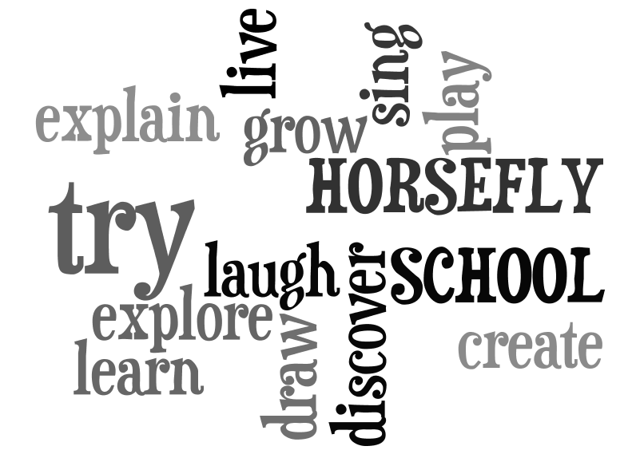

Code of Conduct
2024-2025

HORSEFLY ELEMENTARY JUNIOR SECONDARY SCHOOL
MISSION STATEMENT

Our school is dedicated to developing the full potential of each student. In partnership with the community, we will provide a safe environment where students will develop positive self-esteem as well as acquire the necessary skills and responsible attitudes to becoming caring citizens and independent lifelong learners.

“LEARNING, GROWING AND BELONGING TOGETHER”

SCHOOL DISTRICT #27 MISSION, VISION AND VALUES

HORSEFLY ELEMENTARY/JUNIOR SECONDARY SCHOOL

Box 39
Horsefly, BC
V0L 1L0
Phone: (250) 620-3438
Fax: (250) 620-3468

 | CODE OF CONDUCT
 | A. |  | Purpose:
The contents of this Code of Conduct acknowledge that if there is a conflict between this Code and the BC Human Rights Code then the BC Human Rights Code shall prevail.

The purpose of the Code of Conduct is to inform all members of the school community of our shared obligations and responsibilities to ensure a safe, caring and orderly school environment where students feel a sense of belonging, pride in their school, and where people in the school community are respectful, fair, and where they feel safe to work and learn. The goal is to have students manage their own behaviour.
 | B. |  | Development and Regular Review
 |  | 1. |  |  | At the beginning of the year, students, staff and parents are included in the development of the Code of Conduct during class time and assemblies, through newsletters, and at staff and PAC meetings.
 |  | 2. |  |  | The Code is reviewed and updated in September and June of each school year during school consultation meetings with students, staff and parents. Members from all stakeholder groups are invited to attend meetings.
 |  | 3. |  |  | Conduct is consistently monitored by staff through direct communication and interaction with students. A comprehensive behaviour and intervention plan is utilized to ensure Codes reflect current and emerging situations and are contributing to school safety.
 | C. |  | Communicating Expectations
 |  | 1. |  |  | The Code of Conduct is communicated to staff, students, parents, temporary staff, new members of the school community and visitors. Each family receives a Student Handbook containing the Code of Conduct at the beginning of each year. The Code of Conduct is discussed in classrooms, at assemblies, and at staff and PAC meetings. It is posted in various prominent and highly visible areas in the school.
 | D. |  | Active Teaching and Promotion of Expectations
 |  | 1. |  |  | The school will teach and promote behavioral expectations throughout the school year via classroom discussions, school-wide assemblies and newsletter communications. We have an effective behavior support, which promotes and rewards positive actions, attitudes, and school culture. The guiding principles behind our behavior program are: Be Caring, Effort, Accountability, Respect and Safety (BEARS). The Code of Conduct will also be promoted through regularly scheduled career and personal planning curriculum instruction.
 | E. |  | Expectations of Acceptable Conduct
 |  | 1. |  |  | Acceptable behaviour creates an atmosphere of trust and security in which students may grow in confidence as a result of their actions and achievements: respecting self, others, and the school; helping to make the school a safe, caring, and orderly place; informing an adult in a timely manner of incidents of bullying, harassment, or intimidation; engaging in purposeful learning activities in a timely manner; and acting in a manner that brings credit to the school.
 |  | 2. |  |  | The Code of Conduct conditions apply while students are in attendance at school, while travelling to and from school, and while attending any school function at any location.
 |  | 3.  4. |  |  | We appreciate that parents provide cellular phones for students’ safety and contact but cellular phones are not to be used during class time, unless the classroom teacher has given permission and it is used to support learning. Devices must be turned off and put away out of sight. Devices may be used during non-instructional time on school grounds. Devices may be confiscated and returned to parents when students do not follow this expectation.  School District’s policy regarding the possession or use of weapons:  Policy 5114.1  The Board of Education considers the possession or use of any weapon by anyone on school premises to be a serious threat to the school environment and to the safety of both students and staff.  Weapon:  - Anything that is used, or intended to be used, or is designed to be used to put someone in fear; or  - Anything used or intended for use in causing death or injury to persons whether designed for that purpose or not; or  - Anything used, or intended for use, to threaten or intimidate any person and, without restricting the generality of the foregoing, includes any replica weapon or firearm as defined in the Criminal Code (s. 84).
 |  | 4. |  |  | Prohibited grounds of discrimination set out in the BC Human Rights Code, as they relate to the school environment (s. 7).  People are protected by virtue of their, real or perceived, race, colour, ancestry, place of origin, political belief, religion, marital status, family status, physical or mental disability, age, sexual orientation or gender identification and therefore should not be subjected to discriminatory actions, including publication or discrimination of service.
 |  | 5. |  |  | The Board of Education will take all reasonable steps to prevent retaliation by a person against a student who has made a complaint of a breach of the Code of Conduct.
 |  | 6. |  |  | The conduct of students, school staff, parents, coaches and involved members of the greater community while acting as ambassadors of the school must align to create a safe, caring, and orderly environment where respect, responsibility, kindness, caring and acceptance are upheld.  - In keeping with the focus on preventative and restorative action, positive behaviour support acknowledges acceptable behaviour. The students have opportunities to be championed for positive actions and accomplishments.  - The expectations for behaviour are consistently taught through classroom discussions, newsletters, assemblies, and conversation. The expectations are reinforced through an acknowledgement and celebration of excellence in action and achievement. Each child is evaluated and recognized as an individual, with distinct skills and abilities.
 | F. |  | Levels and Consequences for Unacceptable Conduct
  Level 1 Behaviours
  The attending adult in the classroom handles the following behaviours:
  - Disruptions/disobedience
  - Tardiness
  - Truancy
  - Vandalism (minor) / Theft (minor)
  - Lack of effort
  - Lack of Respect
  - Inappropriate language/behaviour
  - Homework issues
  Assembly / audience behaviour
  Breach of minor school rules/policies
  Personal cellphone use during class time
  Level 2 Behaviours
  The following behaviours are initially dealt with by the attending adult – then reinforced by the office:
  - Lack of Respect (major)
  - Inappropriate language
  - Bullying/ Harassment (major or repeated)
  - Defiance/ Willful disobedience
  - Inappropriate internet use
  - Disrespecting teachers’ personal space and/or belongings
  - Inappropriate representation of school (field trip/athletics)
  - Cheating or Plagiarism
  Level 3 Behaviours
  Immediate office referrals and intervention:
  - Bullying/Harassment/Intimidation/ Inappropriate sexual behaviour
  - Fighting/Assault
  - Direct disobedience or defiance
  - Endangering safety
  - Drugs or alcohol infractions
  - Possession/use of a weapon
  - Smoking/Tobacco
  - Theft (major) and Vandalism (major)
  - Tampering with Emergency Equipment
  SCHOOL-WIDE CONSEQUENCES
  Level 1 Behaviours
  Step 1: Reminder to student of behavioural expectations.
  Step 2: Restitution by the student.
  Documentation by the teacher on the Horsefly Elementary
  Junior Secondary referral sheet
  Step 3: Home contact by the teacher
  Documentation by the teacher on referral sheet
  Step 4: Move directly to “Level 2 – Step 2”
  Level 2 Behaviours
  Step 1: Referral to administration by attending adult with
  documentation by the teacher on Horsefly Elementary Junior Secondary referral sheet
  Home contact by teacher/administration
  Homework Club/Detention
  Step 2: Referral to administration
  Home contact – parent conference
  One to 3 day in-school suspensions
  Step 3: Referral to administration by teacher
  Home contact by administration
  1 - 5 days in or out of school suspension
  Step 4: Move directly to “Level 3 – Step 2”
  Level 3 Behaviours
  Step 1: Referral to administration
  1 - 5 days out of school suspension (10 for drugs/alcohol)
  Parent conference with administration before student returns
  Step 2: 5 - 10 days out of school suspension
  Step 3: Indefinite Suspension – referral to District Discipline
  Committee
CONSIDERATIONS FOR THE CODE OF CONDUCT

We ensure that consequences applied are appropriate for the violation of the Code of Conduct, and we focus on restorative actions rather than those that are punitive in nature.

 | When levying consequences for behaviors of a discriminatory nature, we make every attempt to address all parties involved and develop a plan to address the school culture.
 | We consider a student’s age, maturity and special needs, as well as the student’s previous school record.
We give special considerations to students with special needs if these students are unable to comply with a Code of Conduct due to a disability of an intellectual, physical, sensory, emotional or behaviors.

Students have varying levels of understanding as they grow older and more mature. Conduct expectations for students in the primary grades may be very different than what we would expect of an intermediate student.

The use of suspension is only when violation of the Code is serious or other consequences have been inadequate or ineffective. Violations of the code of conduct often result in notification to relevant stakeholders. When necessary, parents will be notified initially by phone and in more serious circumstances, through official letters. When a letter of suspension is written, the superintendent will be notified, along with the parents. During all courses of action, students will be made aware of the procedures and included in the process of discipline. School officials may have a responsibility to advise other parties of serious breaches of the code of conduct. (e.g., parents, school district officials, police and/or other agencies).

